Mid-Florida  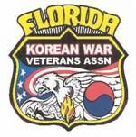  Chapter #173 | KOREAN WAR VETERANS ASSOC  Mid-Florida Chapter #173 INC.  Commander Charles R. Travers  P O BOX 160505  Altamonte Springs, FL 32716-0505  (C) 407-252-0773 CRTravers@Yahoo.com  Gunship442@aol.com | 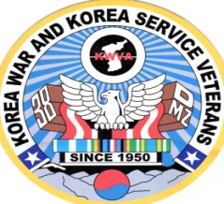

September 12, 2013

Major Frank Medina (USA-Res.)
Chairman
Borinqueneers Congressional Gold Medal Alliance
12671 Lakebrook Dri ve
Orlando, FL 32828

It is with a great deal of pleasure for me to officially inform you that Chapter 173, Mid-Fl Korean War Veterans Association (KWVA), at its Board Meeting on September 3, 2013, approved and highly endorsed the proposal to award the Congressional Gold Medal to the 65th Infantry Borinqueneers.

We are proud of our Borinqueneer members and have honored them in the past.
I’m sure that your diligence and fortitude as well as all members of the Alliance
will achieve this worthy goal.

With best regards,

Chuck
Charles R. (Chuck) Travers
Commander
Chapter 173 (KWVA)

cc:
Bob Hebner
President
Dept. of Florida KWVA

